Simple Checklist of Traits Needed for Personal Growth
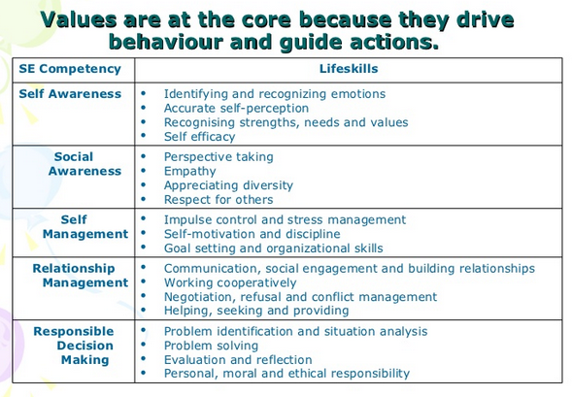
Source: http://www.slideshare.net/MsSharonLim/introduction-to-personal-growth-pg

